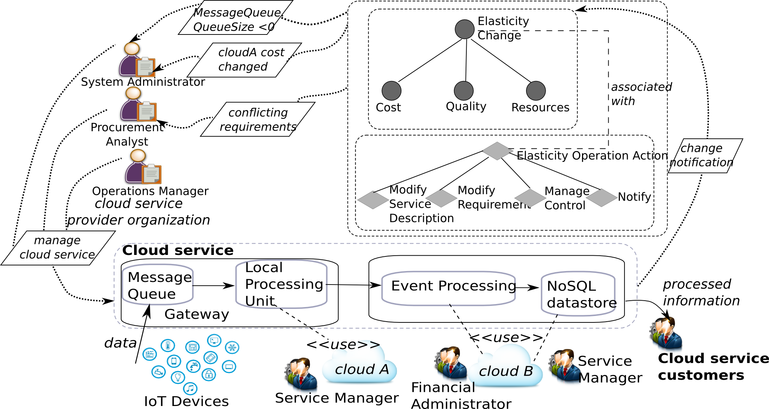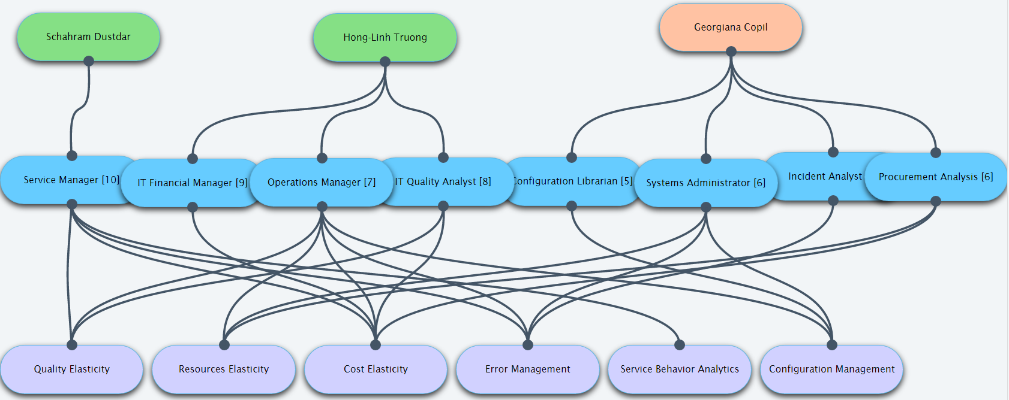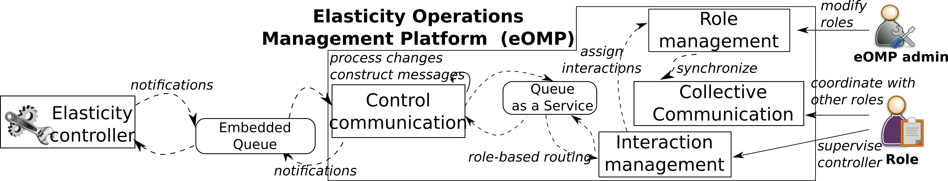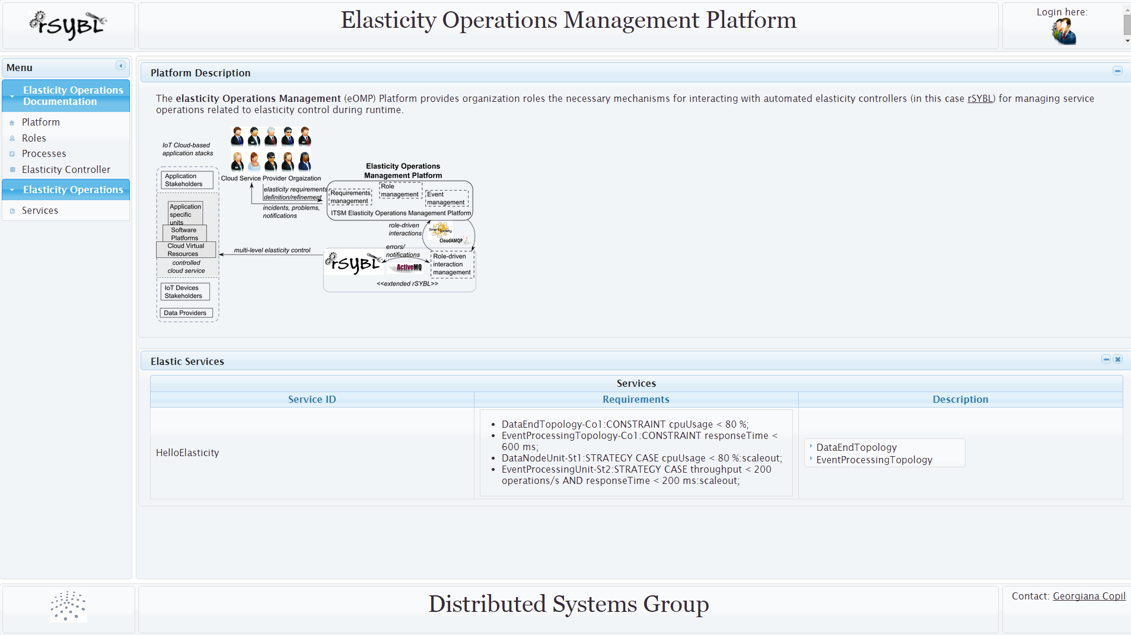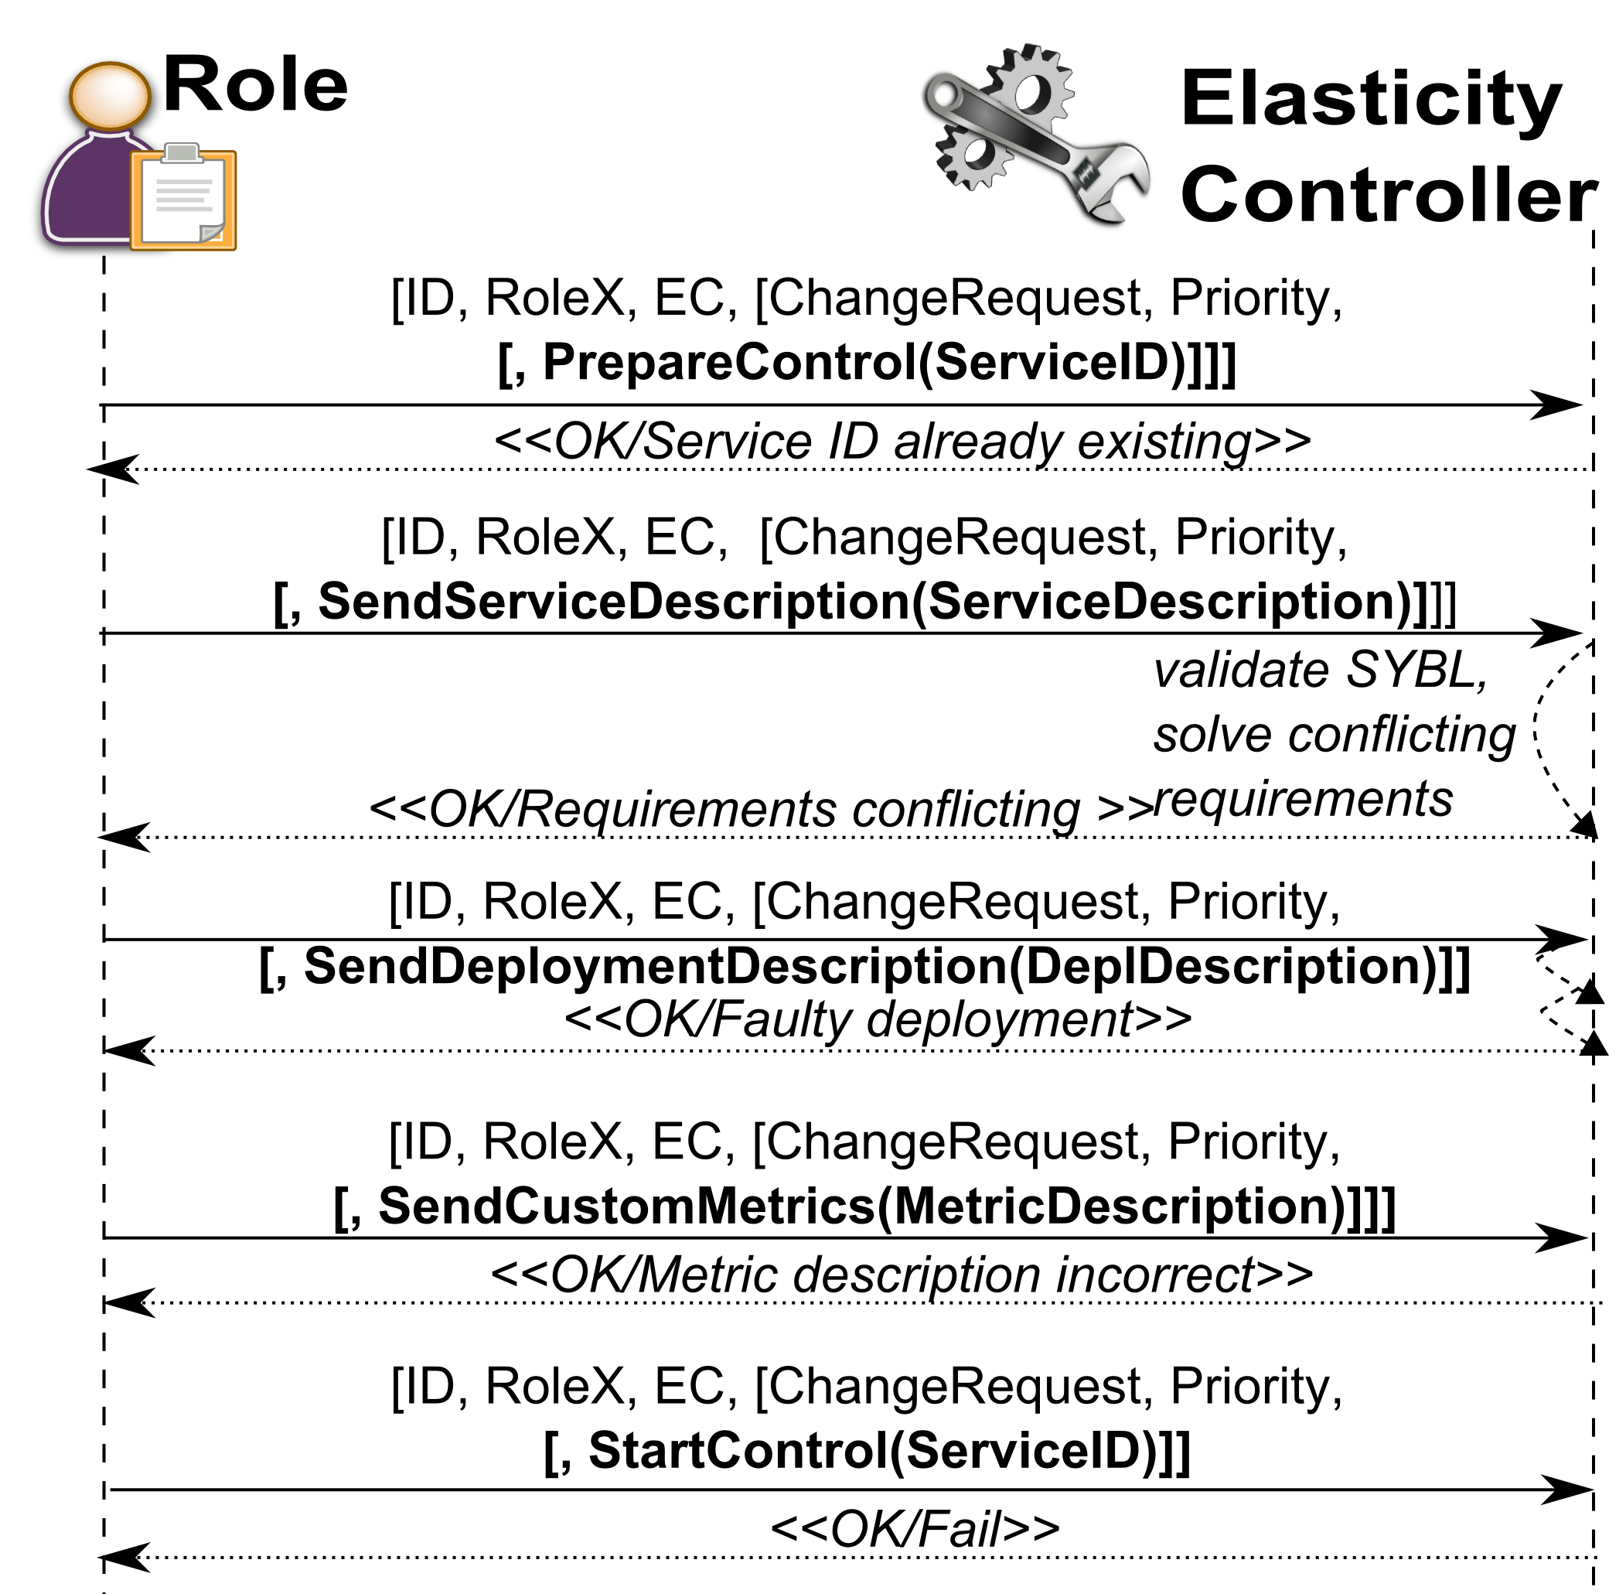

Complex cloud services today rely on various IaaS, PaaS, and SaaS cloud offerings. Fast (re) deployment and testing cycles, and the rapidity of changes of various dependent infrastructures and services, imply a need for continuous adaptation. Although software-based elasticity control solutions can automate various decisions through intelligent decision-making processes, in many cases, such adaptation requires interactions among different cloud service provider employees and among different providers. However, decisions from stakeholders and elasticity software controllers should be seamlessly integrated.

We focus on interactions between service provider employees and elasticity controllers, and propose novel interaction protocols considering various organization roles and their concerns from the elasticity control point of view.

We introduce the **elasticity Operations Management Platform (eOMP)** which supports seamless interactions among service provider employees and software controllers. eOMP provides elasticity directives to enable notifications for complex elasticity issues solved by service provider employees, and the necessary mechanisms for managing cloud service elasticity. We show that, using eOMP, service provider employees can easily interact with elasticity controllers, and, according to their responsibilities, take part in the elasticity control to address issues that may arise at runtime for complex software services.

# eOMP: supporting cloud service operation management for elasticity

## Understanding service provider employees roles means better control for cloud services

Extending eOMP

In case you want to add new features to eOMP, we explain provided hooks for easier extension of the platform.

Using eOMP

In this section we detail the necessary steps for using eOMP.

This part presents an overview of eOMP, the platform we propose for managing service elasticity operations.

Overview

Introducing eOMP

#

**Overview**

The elasticity Operations Management Platform (eOMP) is implemented as a Java enterprise application, which can be deployed either in the cloud or under service provider's premises. eOMP is open-source and available together with further experiments, details and user guide [1]. The current version integrates with the rSYBL elasticity controller, making use of the notification queue (i.e., embedded queue in the eOMP design, implemented using ActiveMQ[2]) exposing events during runtime. This can be easily extended to other elasticity controllers, by implementing an adapter for receiving and processing events. The service queue is using CloudAMQP[3], which is managed RabbitMQ[4] offered as a cloud service. Our Primefaces[5]-based frontend includes dynamically generating diagrams and charts for the cloud service provider employees.

The image above shows the roles present in our eOMP platform, with their associated responsibilities. This diagram can be accessed from the eOMP web interface, showing on the first line the service provider employees, on the second line their associated roles and on the third line the responsibilities that they have (e.g., quality elasticity management, resource elasticity, cost elasticity, error management). The current user in the snapshot above is Georgiana Copil, who has associated roles Configuration Librarian with authority 5, System Administrator with authority 6, Incident Analyst with authority 8, and Procurement Analyst with authority 6. With this view, the current employee can see his/her roles, and the roles of other employees, in order to understand the structure of the service provider organization, and the responsibilities associated with them.

A demo video of eOMP is available at <https://www.youtube.com/watch?v=o-D3rXrNp4c>

**Using eOMP**

For using eOMP, some steps need to be followed firstly for starting the elasticity controller, and then for starting eOMP.

1. Download, configure and start rSYBL elasticity controller: http://tuwiendsg.github.io/rSYBL
2. Download eOMP https://github.com/tuwiendsg/rSYBL/tree/master/eOMP
3. Configure eOMP:
   1. **ControllerCommunication** - The controller communication interacts with rSYBL and with ElasticityOperationsManagementPlatform via 2 types of queues: (1) local activemq queue and (2) CloudAMQP service.
      1. rSYBL queue configuration
         1. QueueUrl =tcp://localhost:61616
         2. QueueName=events
         3. EventQueueEnabled=trueElasticityOperationsManagementPlatform
      2. CloudAMQP configuration
         1. InteractionTopicName=eOMP
         2. CloudAMQPUri=
         3. CloudAMQPPassword=
         4. CloudAMQPVirtualHost=
         5. CloudAMQPUsername=
   2. **ElasticityOperationsManagementPlatform** 
      1. Queue configuration - it interacts with ControllerCommunication via CloudAMQP queue – the configuration in a.ii should be the same as the one in b.i for ControllerCommunication and ElasticityOperationsManagementPlatform component to be able to communicate.
         1. InteractionTopicName=eOMP
         2. CloudAMQPUri=
         3. CloudAMQPPassword=
         4. CloudAMQPVirtualHost=
         5. CloudAMQPUsername=
      2. Database configuration
         1. For persistence we currently use H2 database at jdbc:h2:tcp://localhost/~/omp; - the connection url can be set from src/main/resources/META-INF/persistence.xml
         2. Create further users and roles before logging in eOMP to reflect your organization
         3. Further info on H2 can be found at <http://www.h2database.com/> -
4. Use eOMP
   1. Start the ControllerCommunication, and then start the ElasticityOperationsManagementPlatform (use [Tomee](http://tomee.apache.org/apache-tomee.html) for deploying the platform)
   2. The first page displays the services which are currently controlled, their requirements, the capabilities of the controller and the capabilities of eOMP
   3. After logging in, one can visualize the other employees and their responsibilities, as well as its own responsibilities.
   4. Its own responsibilities details can be viewed by selecting the responsibilities item in the left menu.
   5. By selecting interactions (of different types) the user can see interactions initiated towards him/her so far, and can respond to them by clicking the respond button.
   6. A set of interactions semantically connected is called a *dialog.* By selecting a dialog, one can select from the context menu the “Dialog” option, which loads a diagram showing visually the dialog.
   7. The high authority roles can also see statistics on how interactions have been ongoing. Since interactions are aggregated, and the aggregation level depends on the roles authority and its responsibilities, the higher authority roles, with higher-level responsibilities, will receive less or even no interactions while the lower level authority roles can receive hundreds of interactions.

### eOMP

##### (Continued)

**Extending eOMP**

For extending eOMP in order to better map to the organization which wants to use it, the following options are available:

* In ControllerCommunication component:
  + Create a new client, for a different controller, by implementing the ControlClientInterface
  + Replace the cloudAMQP queue with a different queue, by replacing the CloudAMQPInteractions in InitiateInteractions class
* In ElasticityOperationsManagementPlatform
  + Replace the h2 database in persistence.xml with one better set for your needs
  + Split the jpa-ejb-user interface sub-modules if distribution is needed
  + Replace the cloudAMQP queue with a different queue, by replacing the CloudAMQPInteractions in InteractionManagementSessionBean

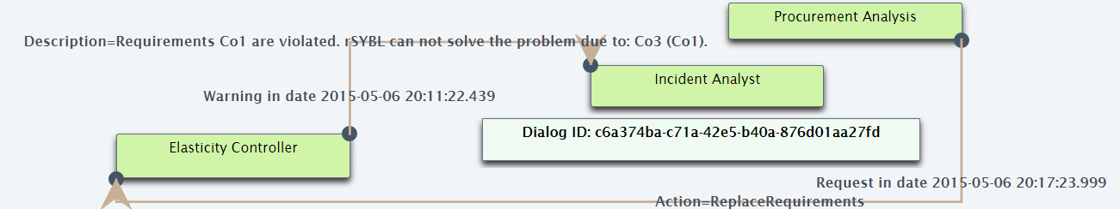

For any kind of question, please contact Georgiana Copil:

* <http://dsg.tuwien.ac.at/staff/ecopil>
* [e.copil@dsg.tuwien.ac.at](mailto:e.copil@dsg.tuwien.ac.at)

References

1. <http://tuwiendsg.github.io/rSYBL/eOMP>
2. <http://activemq.apache.org>
3. <http://rabbitmq.com>
4. <http://cloudamqp.com>
5. <http://rabbitmq.com>
6. <http://www.primefaces.org>

DISTRIBUTED SYSTEMS GROUP

Vienna University of Technology

Institute of Information Systems 184/1  
Distributed Systems Group

Argentinierstrasse,8,  
A-1040 Wien, Austria

### eOMP